PRE-EXECUTION REVIEW AND APPROVAL (Print Name, Sign and Date)
Author | Sharmila Biswas | Signature and Date | REFER TO SDLC-12703 FOR PRE-APPROVED TEST
Service Owner | Prashant Dubey | Signature and Date | REFER TO SDLC-12703 FOR PRE-APPROVED TEST
IT Technical Owner | Michael Benedetti | Signature and Date | REFER TO SDLC-12703 FOR PRE-APPROVED TEST
Independent Quality | Cassandra King | Signature and Date | REFER TO SDLC-12703 FOR PRE-APPROVED TEST

TEST EXECUTION
Environment | QA/Test Production
TESTER DETAILS (By completing the fields below, the tester certifies that they have executed the script, captured and attached all the required test evidence)
Tester | Ajai Omtri | Signature and Date |  | Initials | AJ | Test Run ID | EDL-1, EDL-2,EDL-3, EDL-4, EDL-5, EDL-6,EDL-7, EDL-8, EDL-9, EDL-10,EDL-11, EDL-12

TEST CONCLUSION (Pass or Fail) |  | PASS FAIL
POST-EXECUTION REVIEW AND APPROVAL (Print Name, Sign and Date)
Tester | Refer to teters in the above section |  | Signature and Date
Service Owner | Prashant Dubey |  | Signature and Date
IT Technical Owner | Michael Benedetti |  | Signature and Date
Independent Quality | Cassandra King |  | Signature and Date

Test Script ID | EDL-4 | Version | 1.0 | Test Script Title | EDL Sentry roles availability testing

Test Description | Test whether all the sentry roles from the old cluster are copied over to the new cluster.
Requirement Reference | I_AUT_0020
Pre-Requisites | Tester should have access to  - Able to login to HUE UI of both new and old cluster  - Should have read access on public_core,v_access_rights table on both Old and New Impala Databases

Step | Step Description | Expected Results | Actual Results | Pass / Fail | Defect ID
1 | - Login to HUE UI of Old cluster and Navigate to Security -> Hive Tables ->Roles  - Type the project number in the search box , role and associated AD group will be visible  - Repeat Step B for each project | - Output of query in Step B must match for both New and Old clusters | Output listed that the roles are matching from the old cluster to the new cluster.  Test was executed for Group A migration and no defects were identified. | Pass Fail | N/A

GROUP 1 TEST EXECUTION EVIDENCE:

Old Cluster:

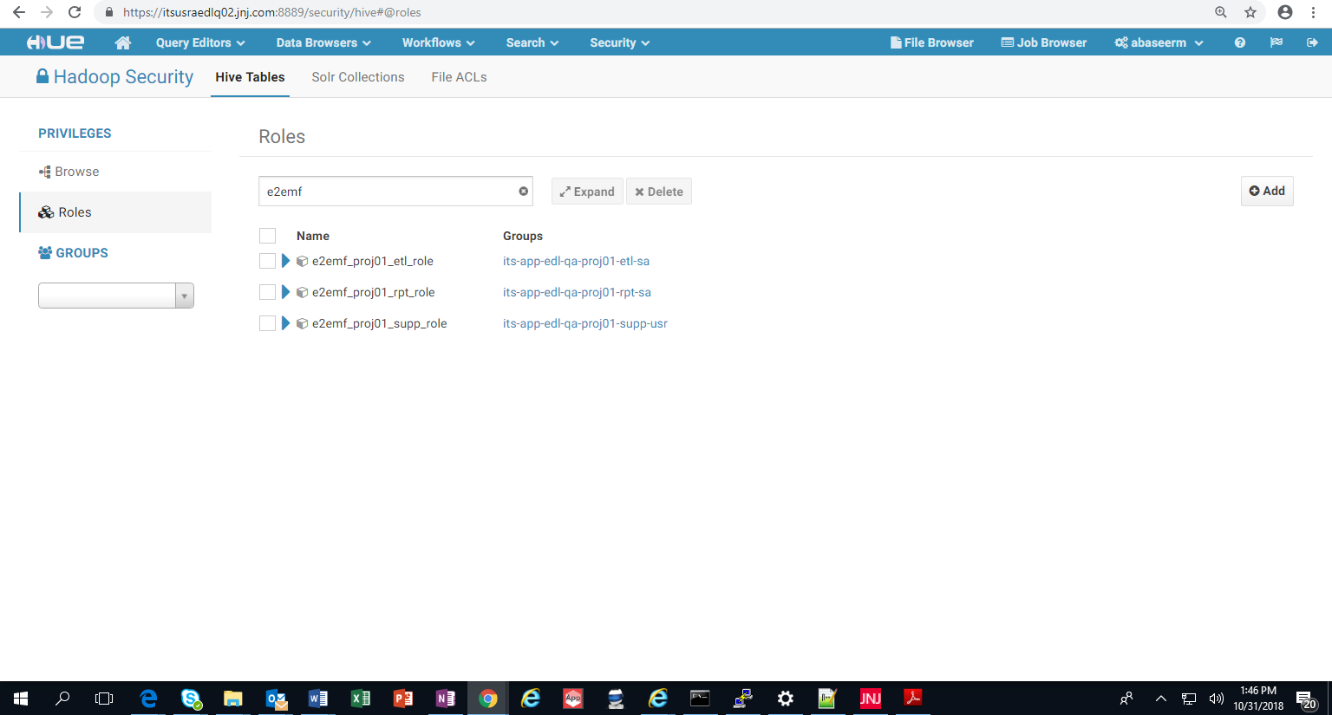

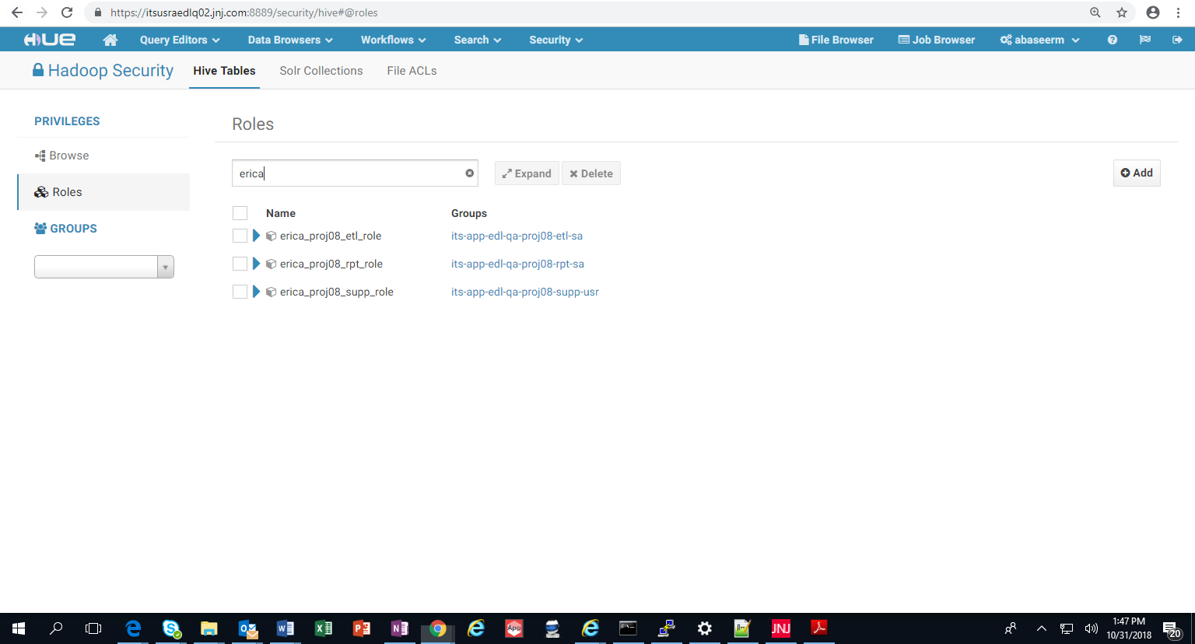

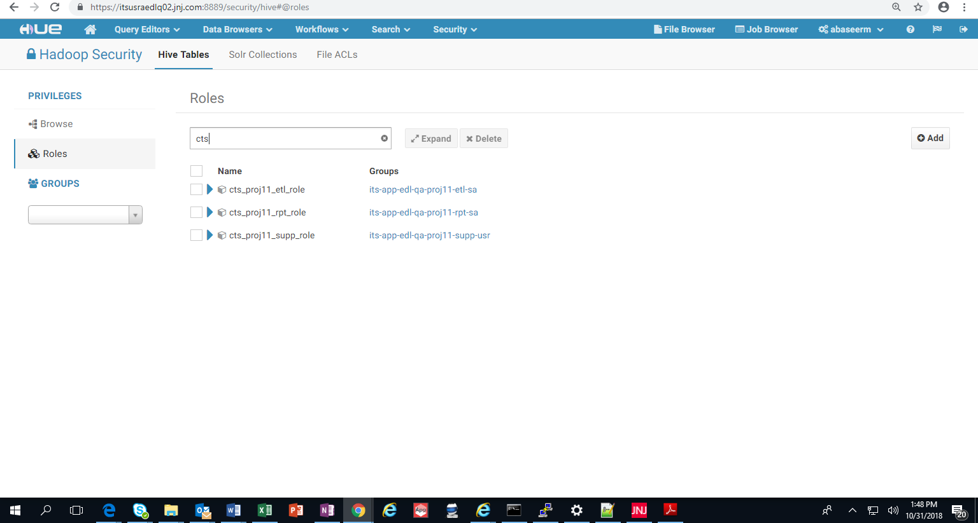

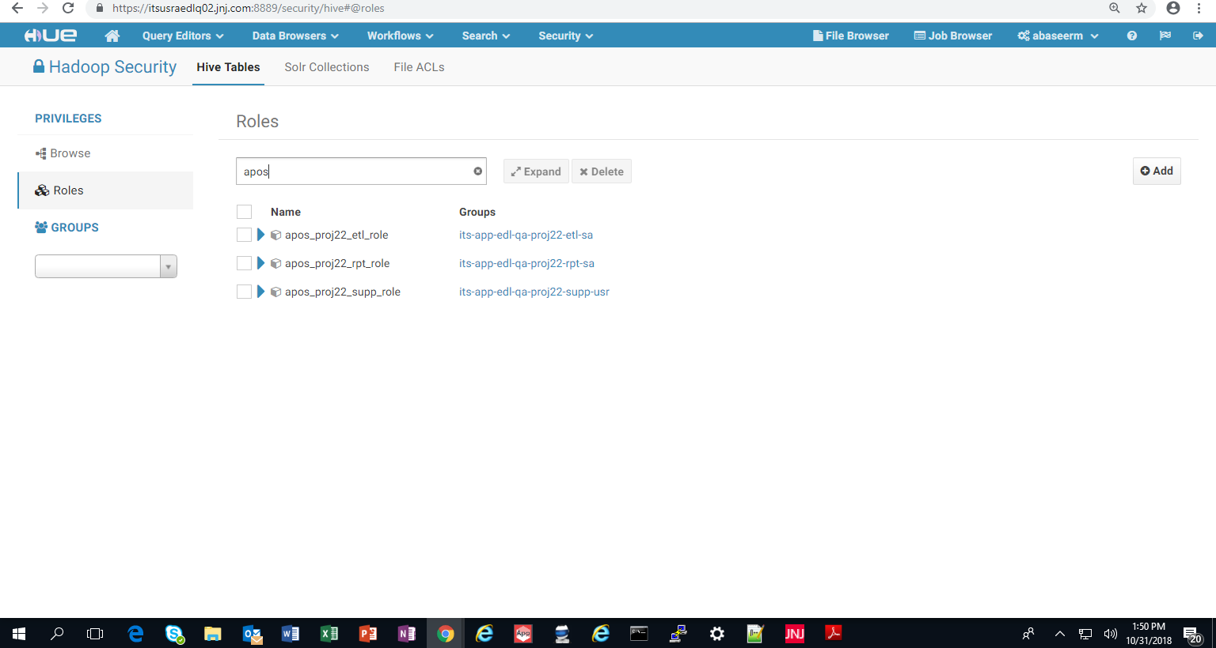

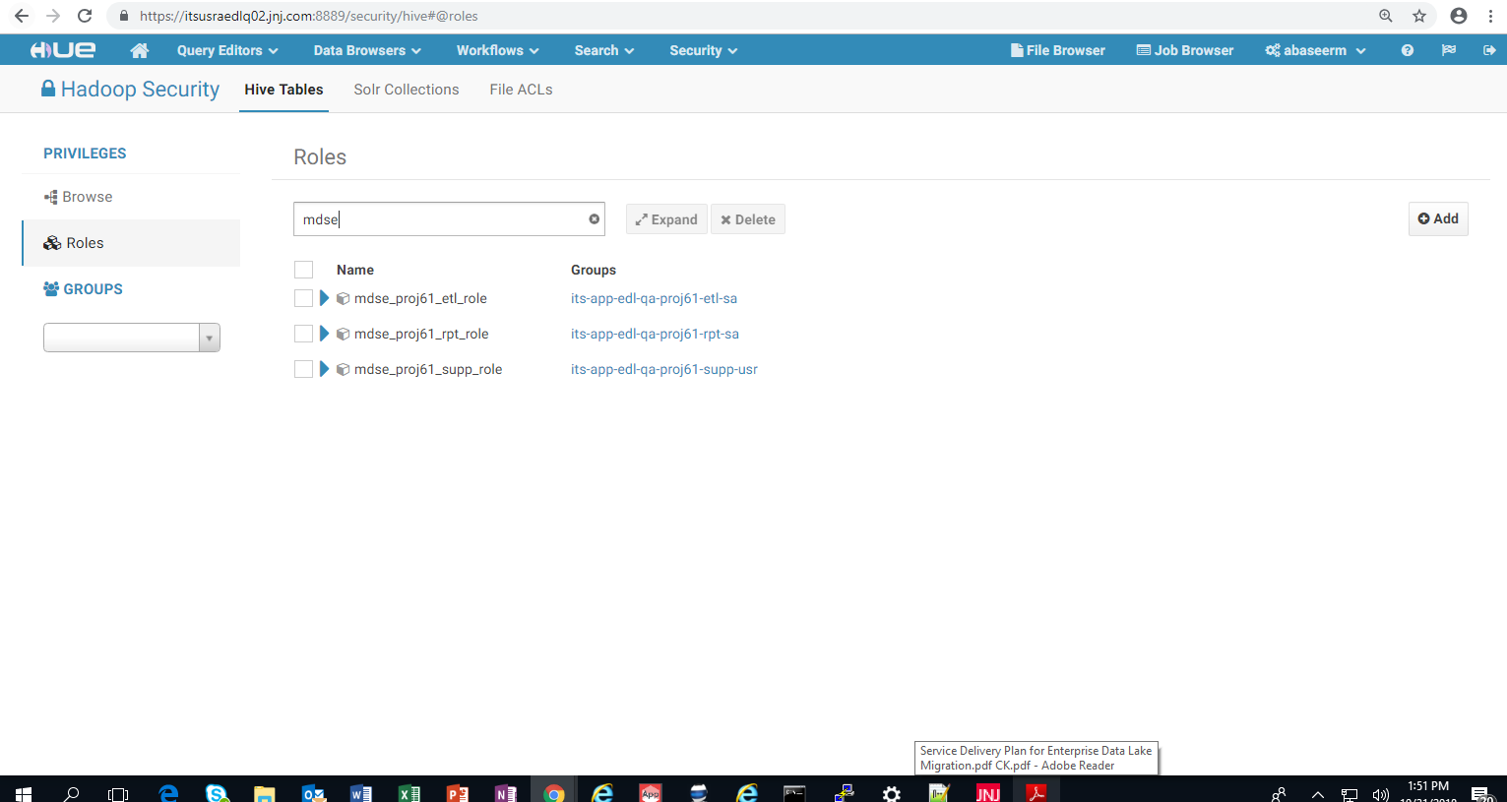

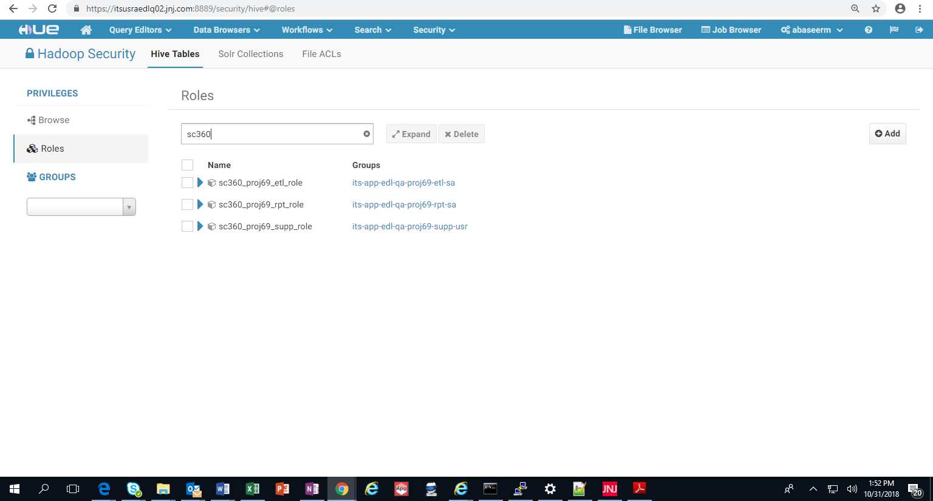

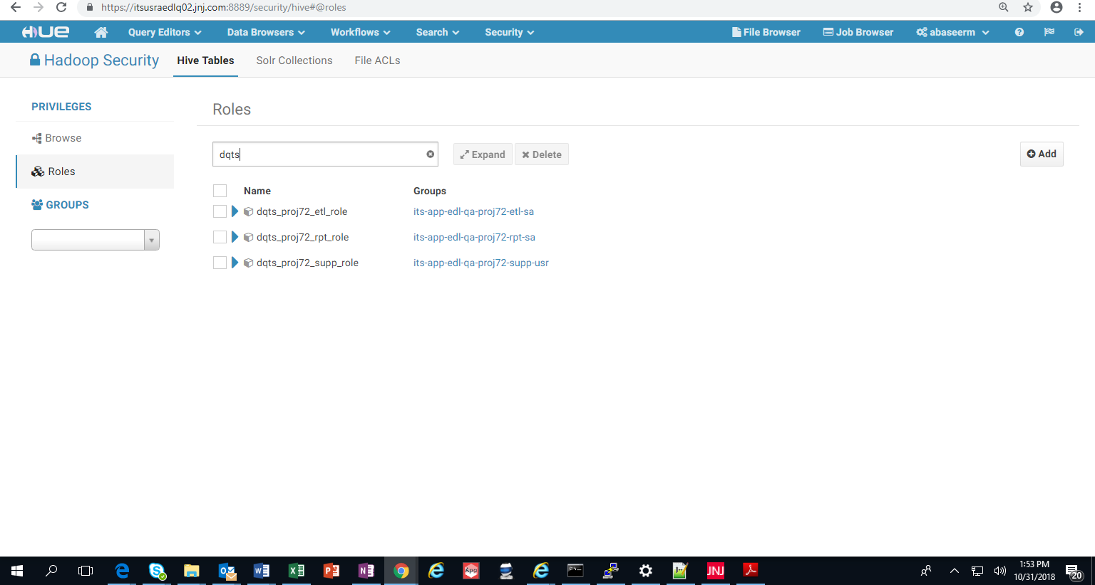

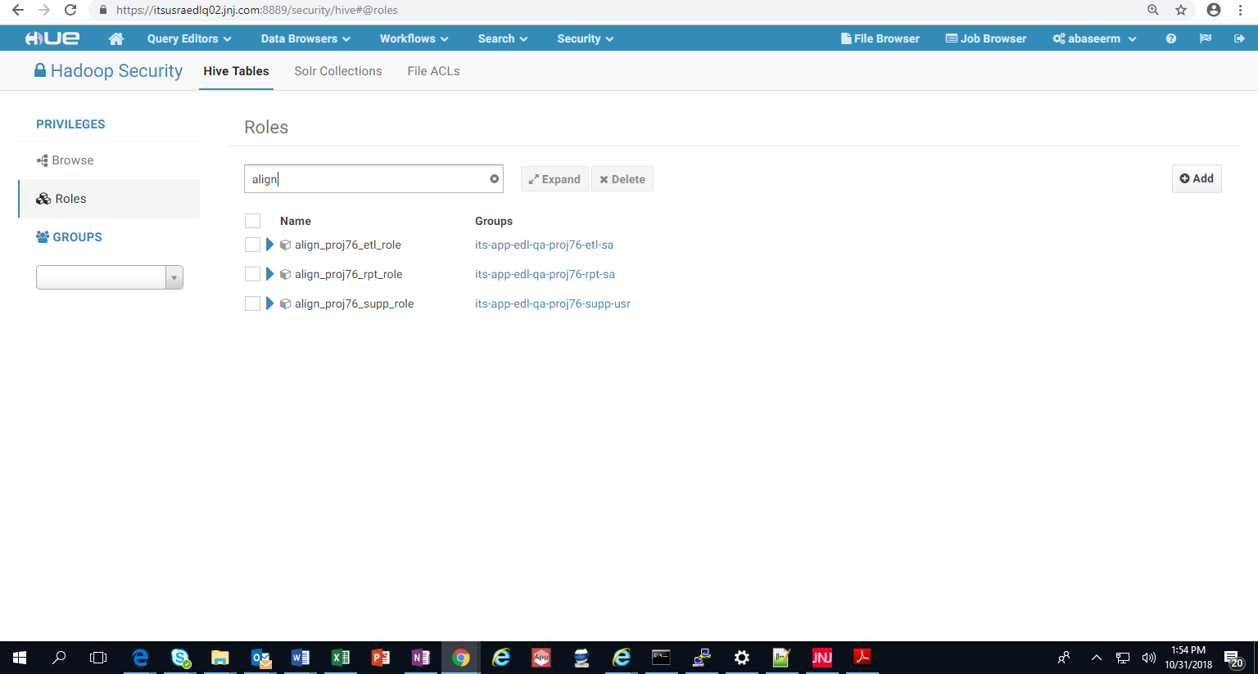

GROUP 1 TEST EXECUTION EVIDENCE:

New Cluster:

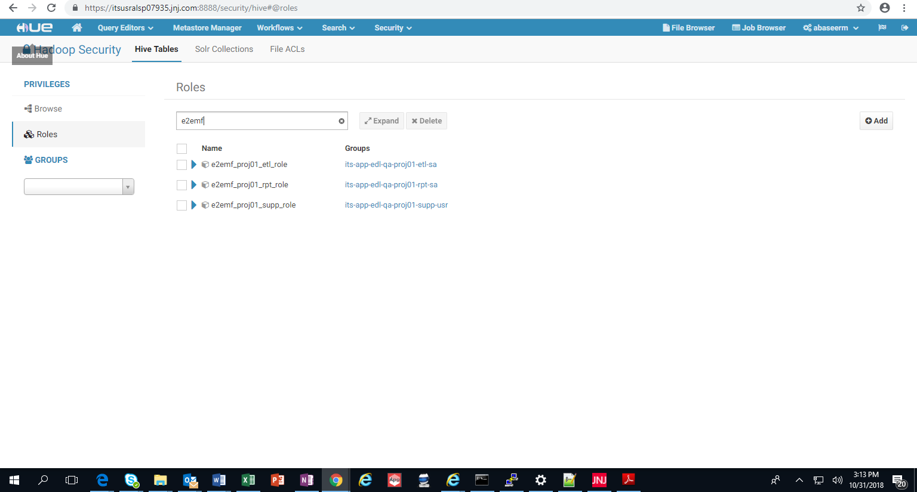

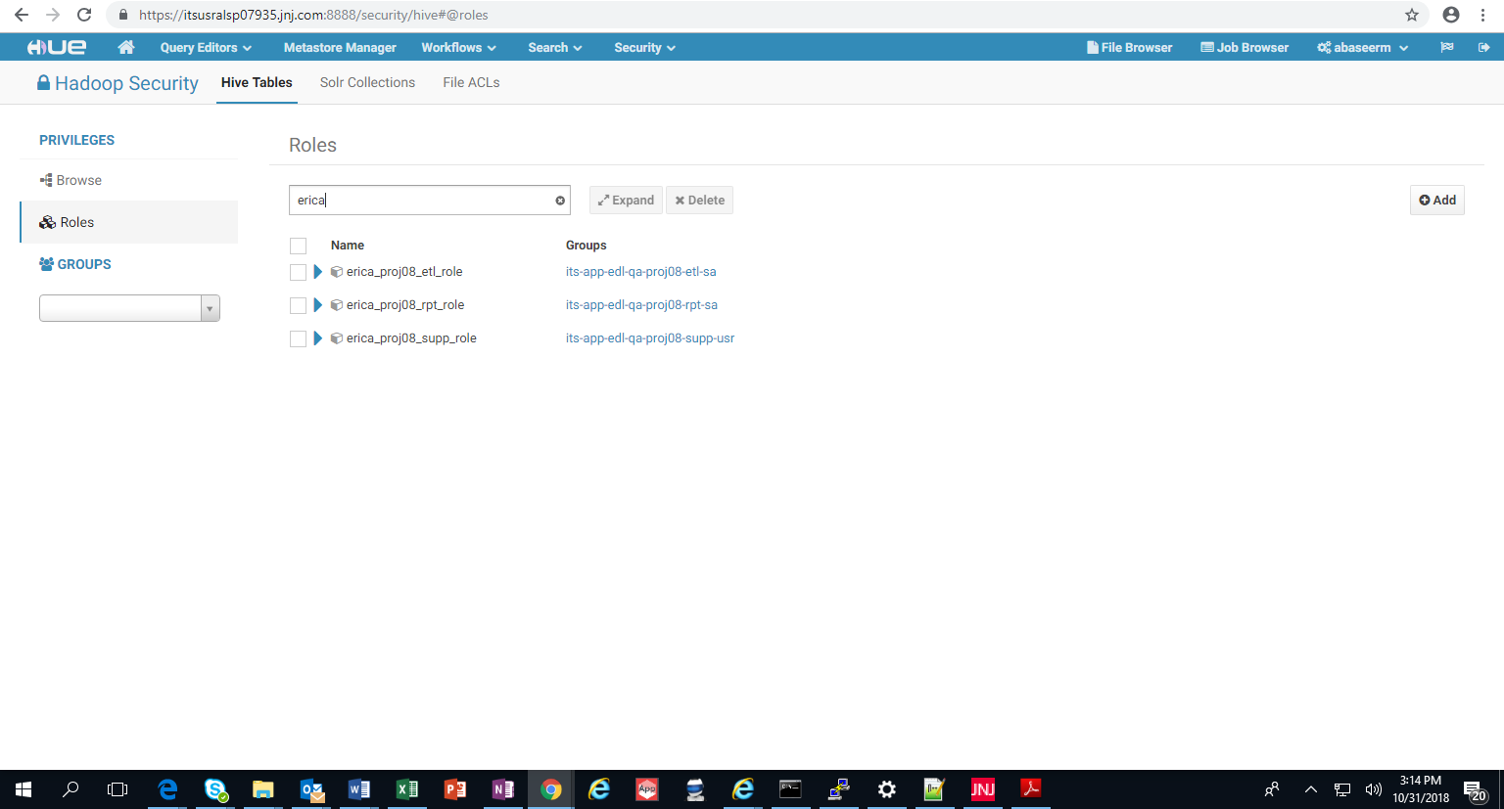

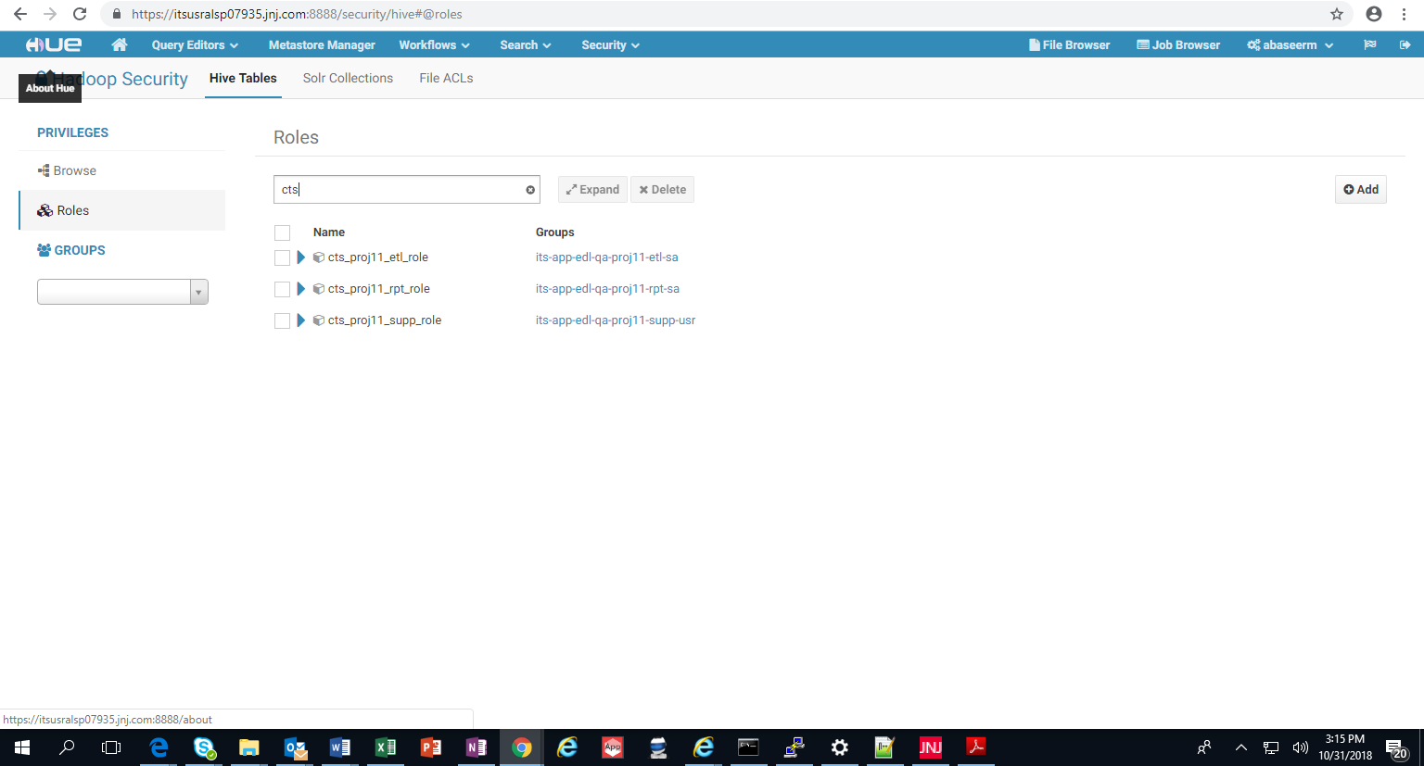

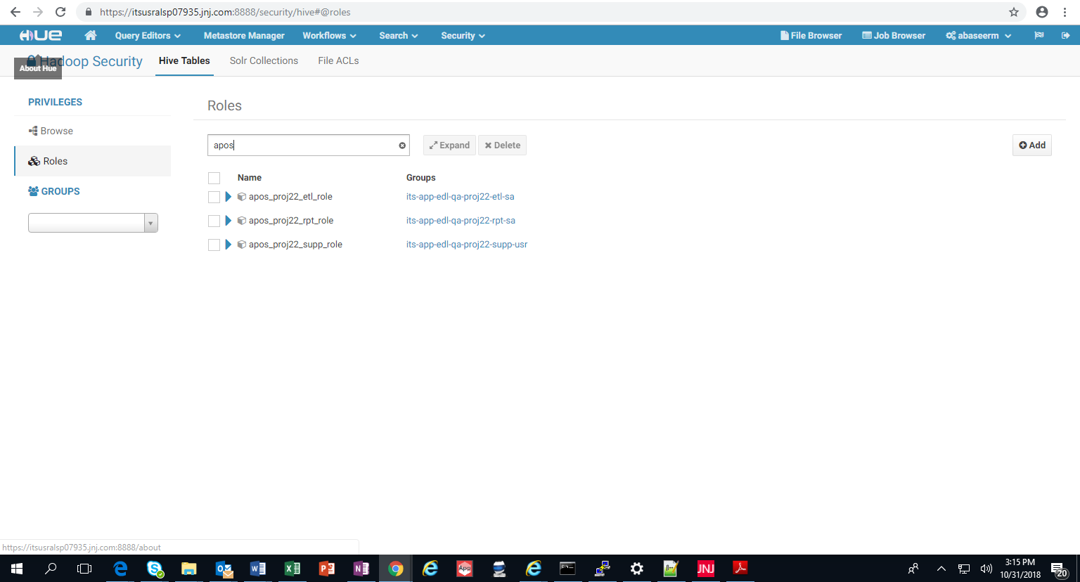

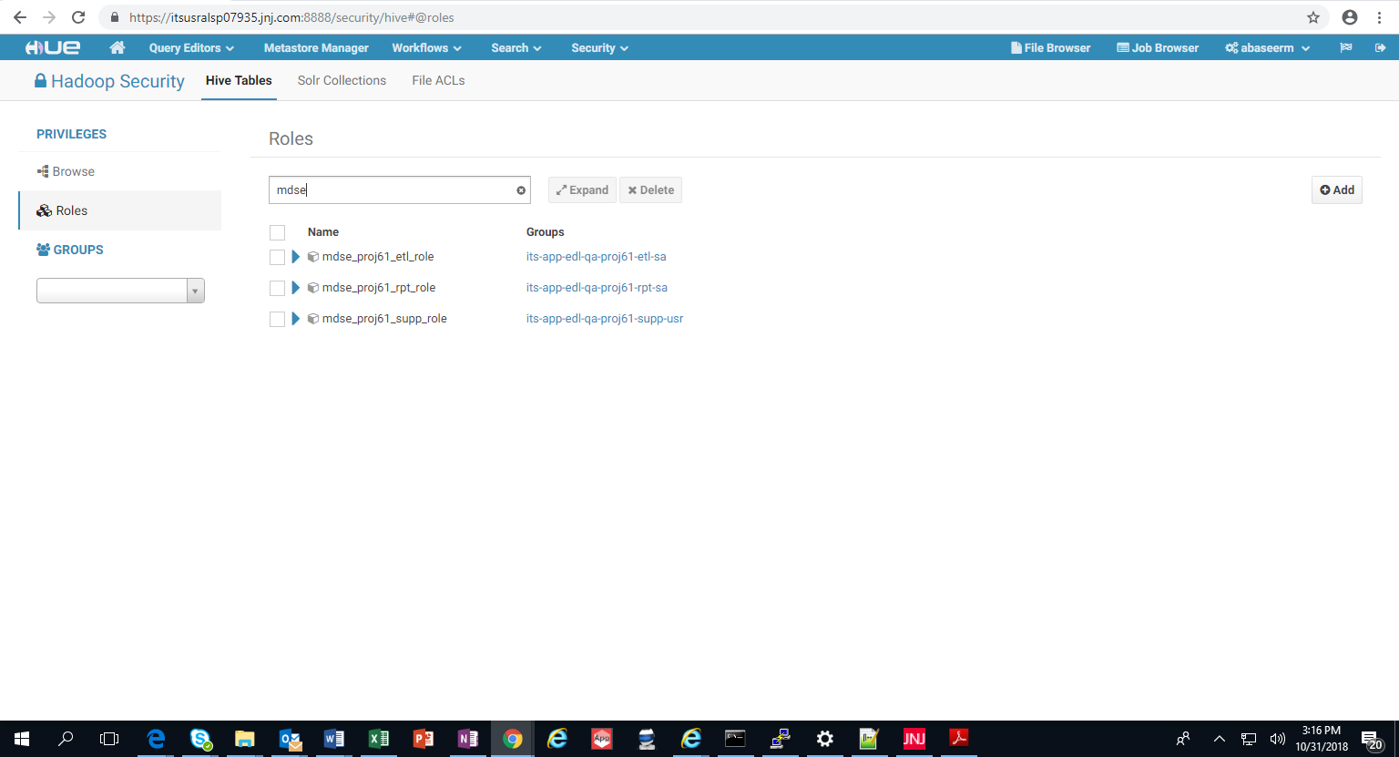

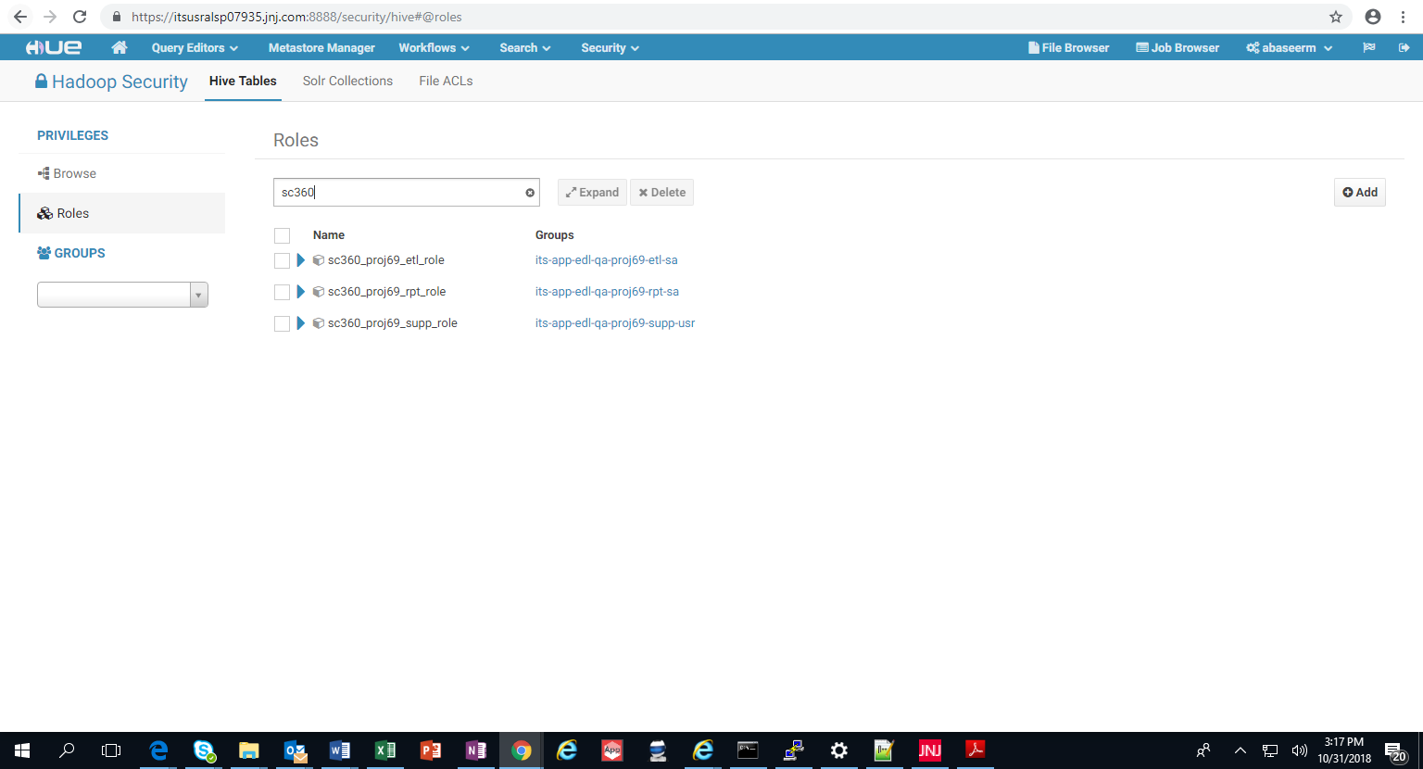

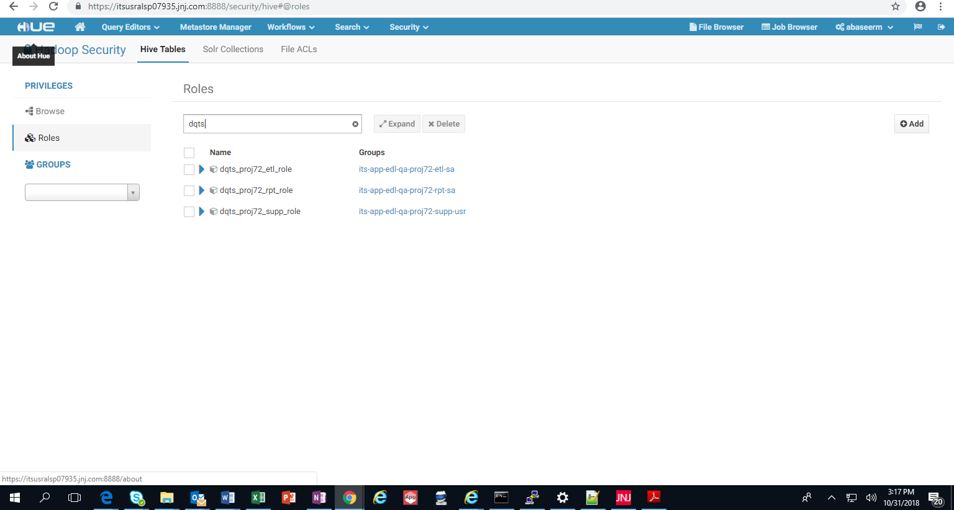

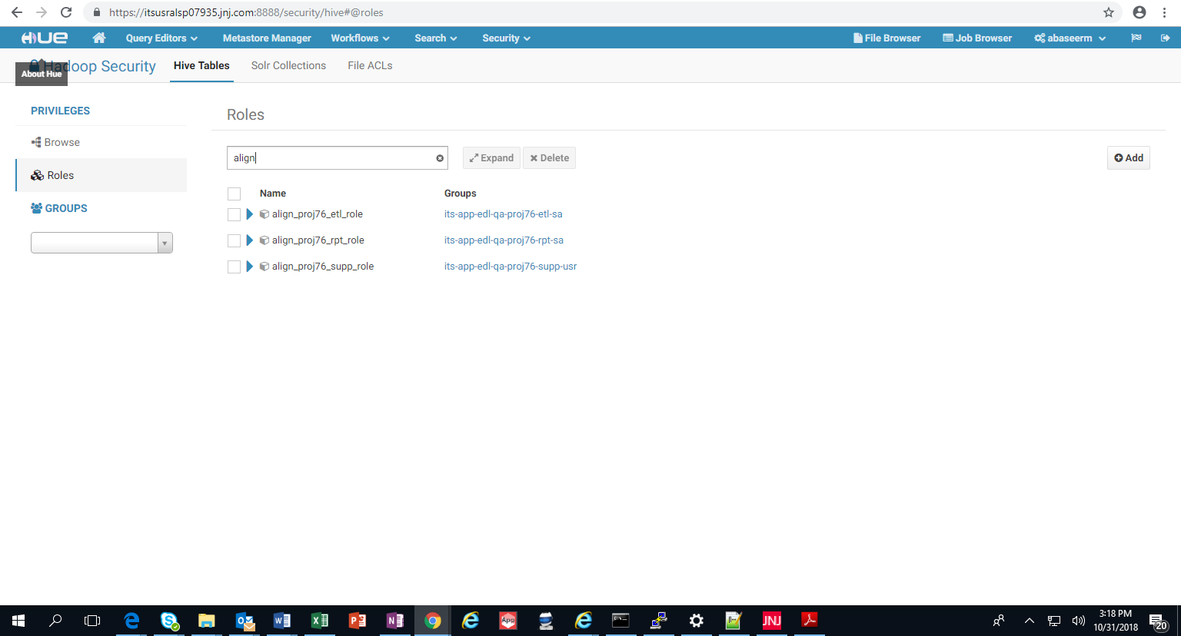

Test Script ID | EDL-7 | Version | 1.0 | Test Script Title | EDL databases are migrated successfully

Test Description | The new cluster shall have the same number of databases as old cluster for the migrated projects.
Requirement Reference | I_MIG_0010
Pre-Requisites | Tester should have  - Access to run show database command in Impala on both new and old cluster  - Able to login to HUE UI of both new and old cluster

Step | Step Description | Expected Results | Actual Results | Pass / Fail | Defect ID
1 | - Login to HUE UI of Old cluster and Navigate to Query Editor -> Impala  - Run these queries for all the migrated databases:  1. show databases like '*cmal*'  2. show databases like '*smbc*'  3. show databases like '*efm*'  4. show databases like '*atom*'  5. show databases like '*epiin*'  6. show databases like '*crspln*'  - Run the queries in Step C on HUE UI of new clusters | Output of the queries for each database must match in both the Clusters HUE UI | Ouput shows that the databases match on both the old and new HUE UI clusters.  Test was executed for Group A migration and no defects were identified. | Pass Fail | N/A

GROUP 1 TEST EXECUTION EVIDENCE:

Old Cluster:

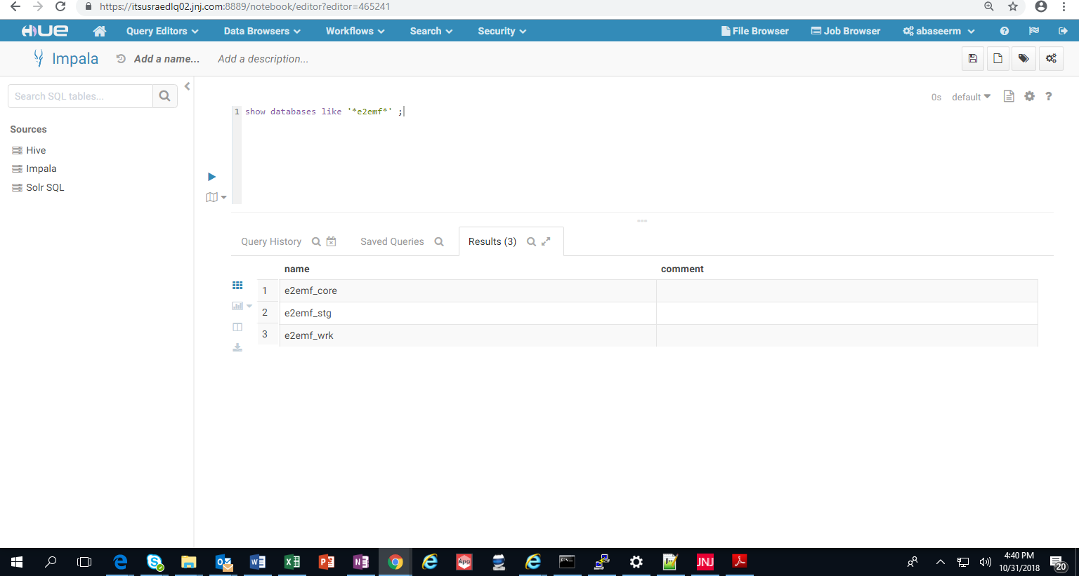

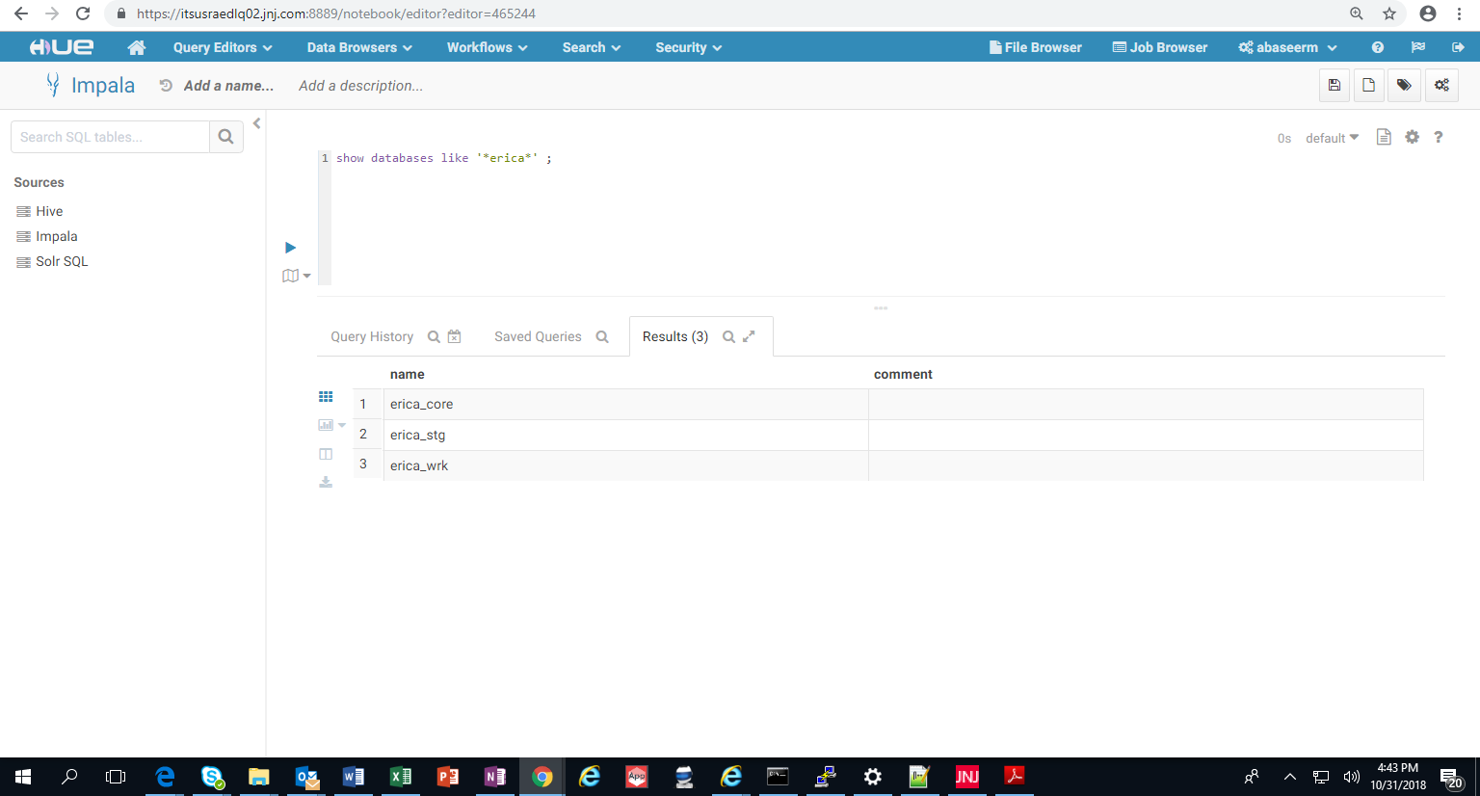

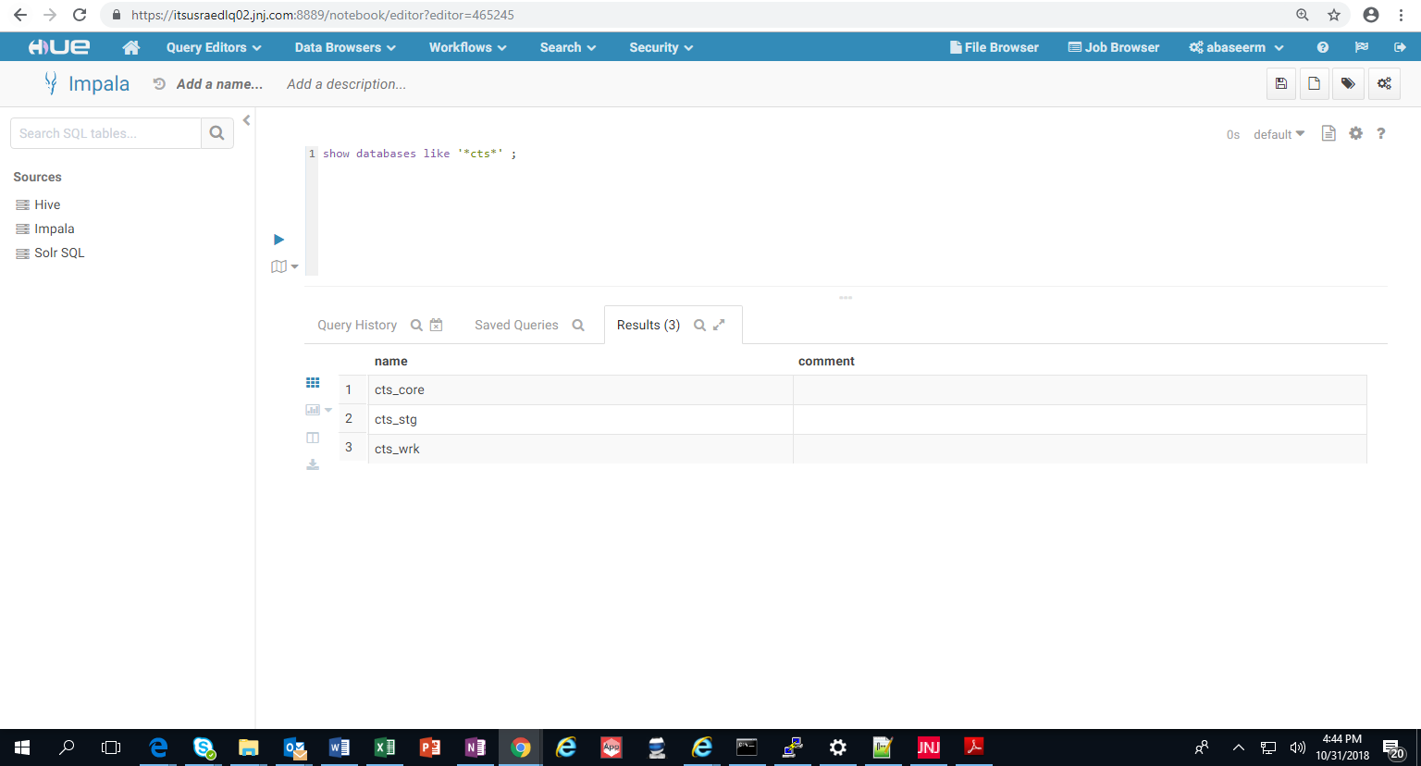

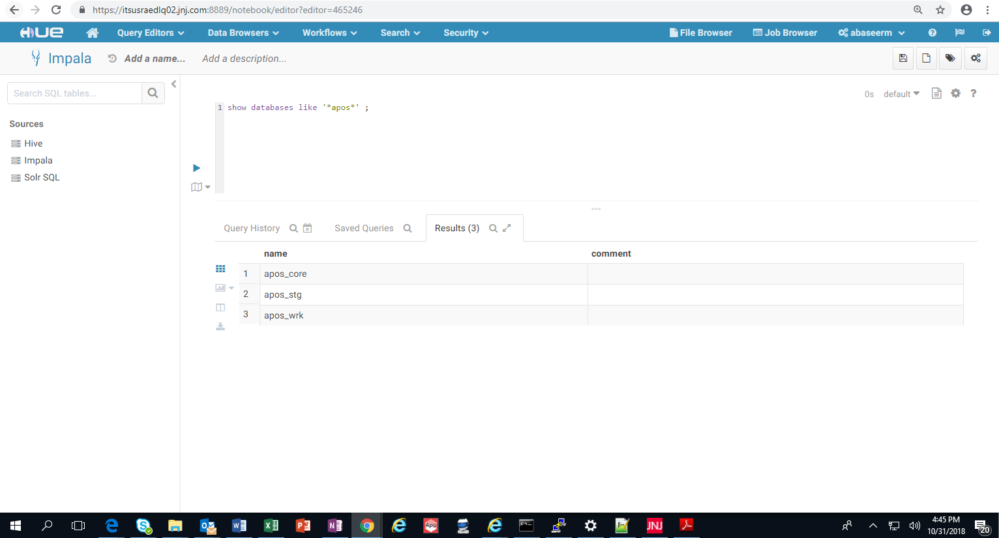

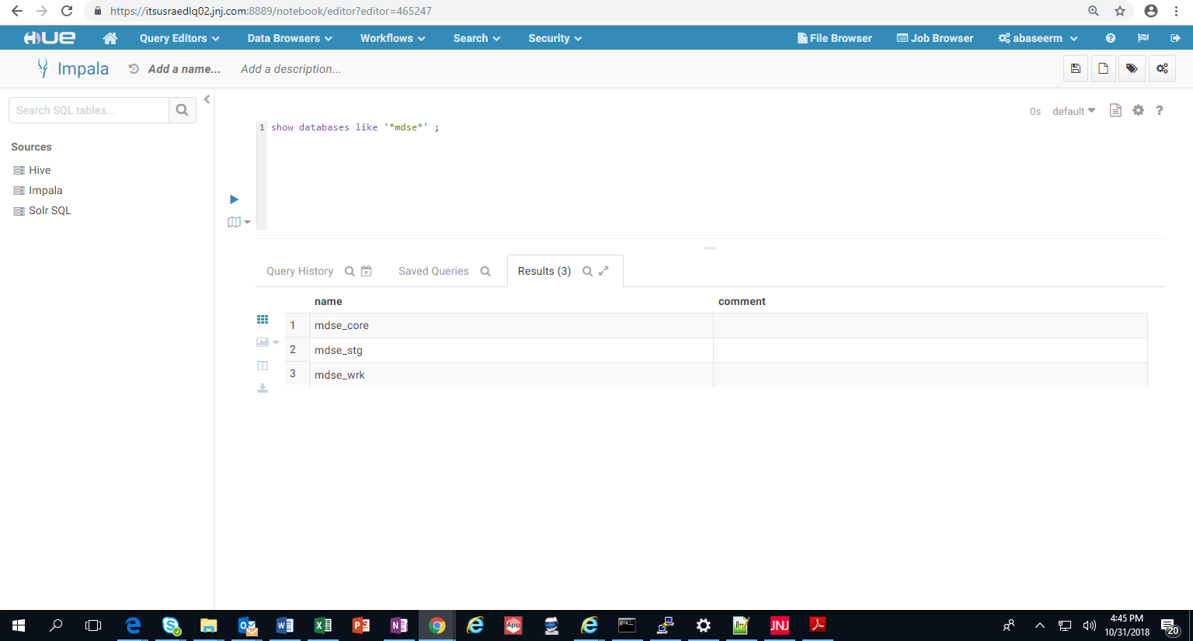

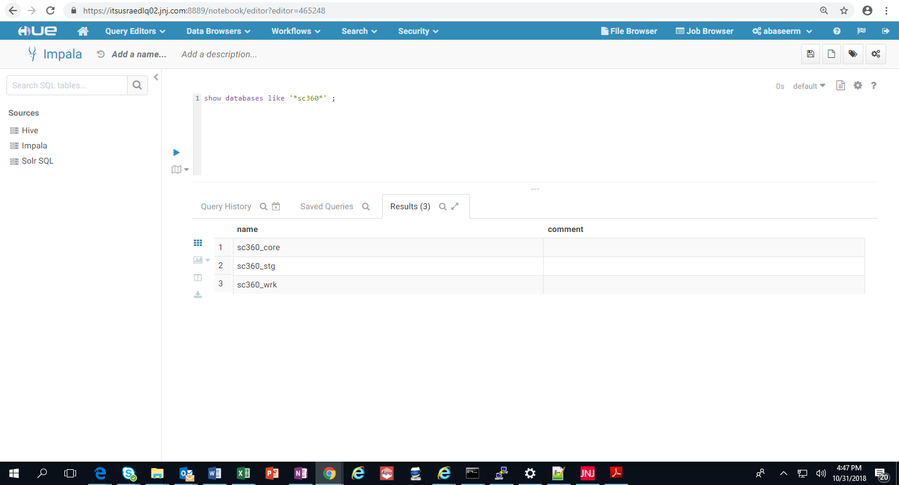

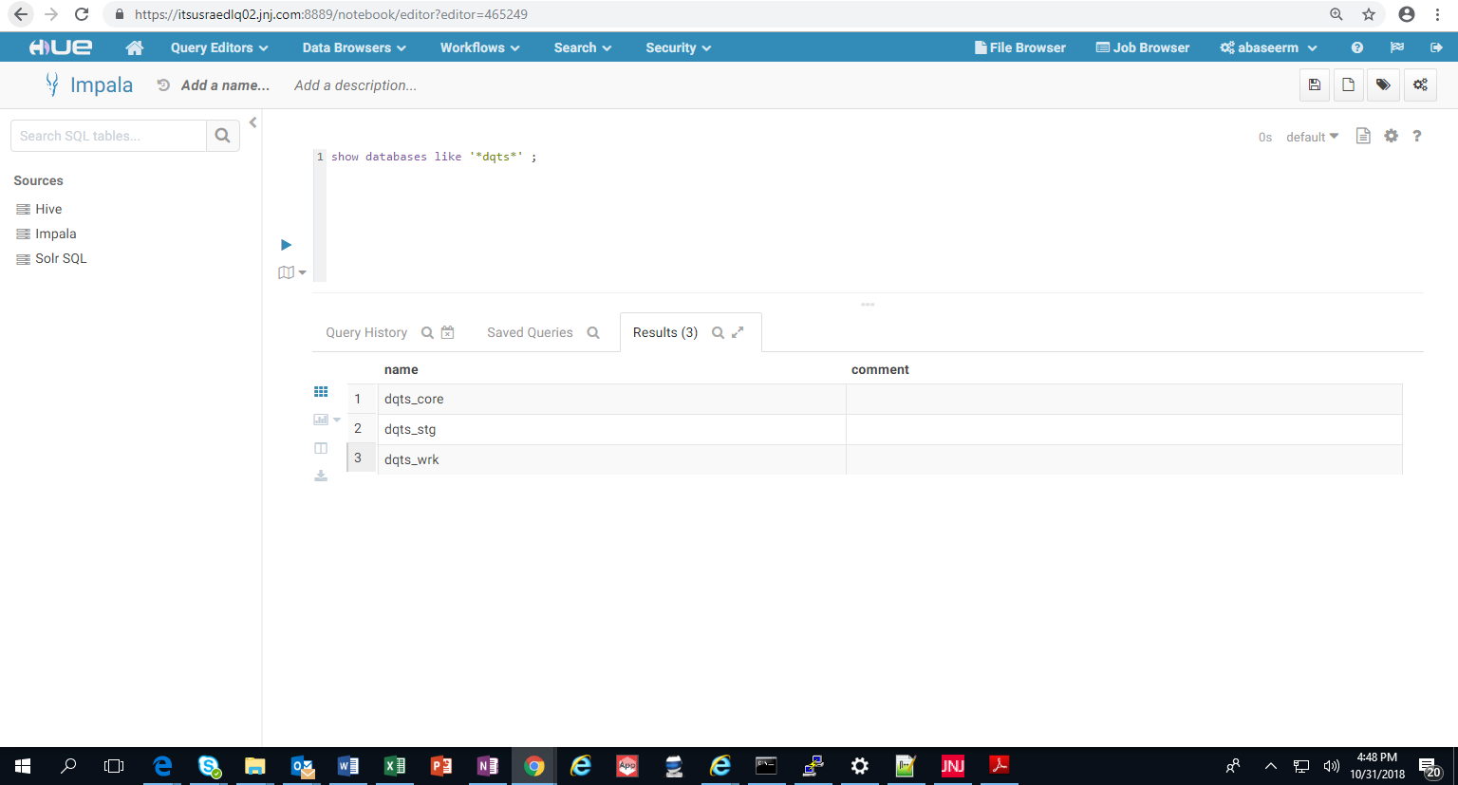

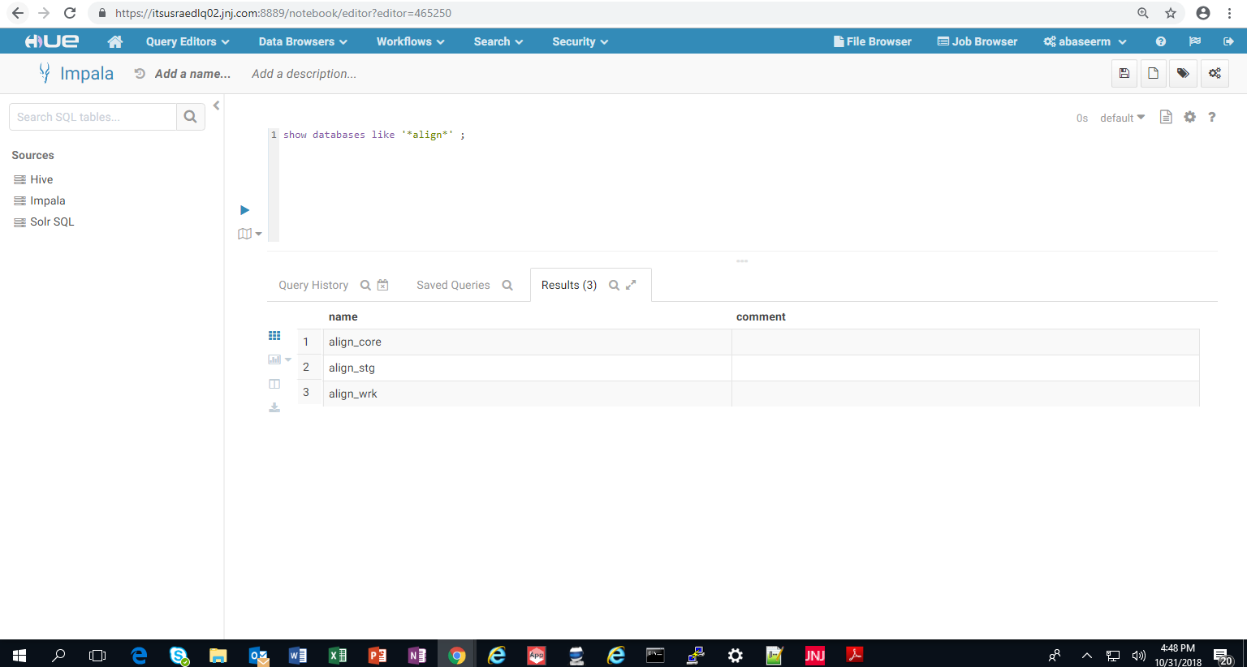

GROUP 1 TEST EXECUTION EVIDENCE:

New Cluster

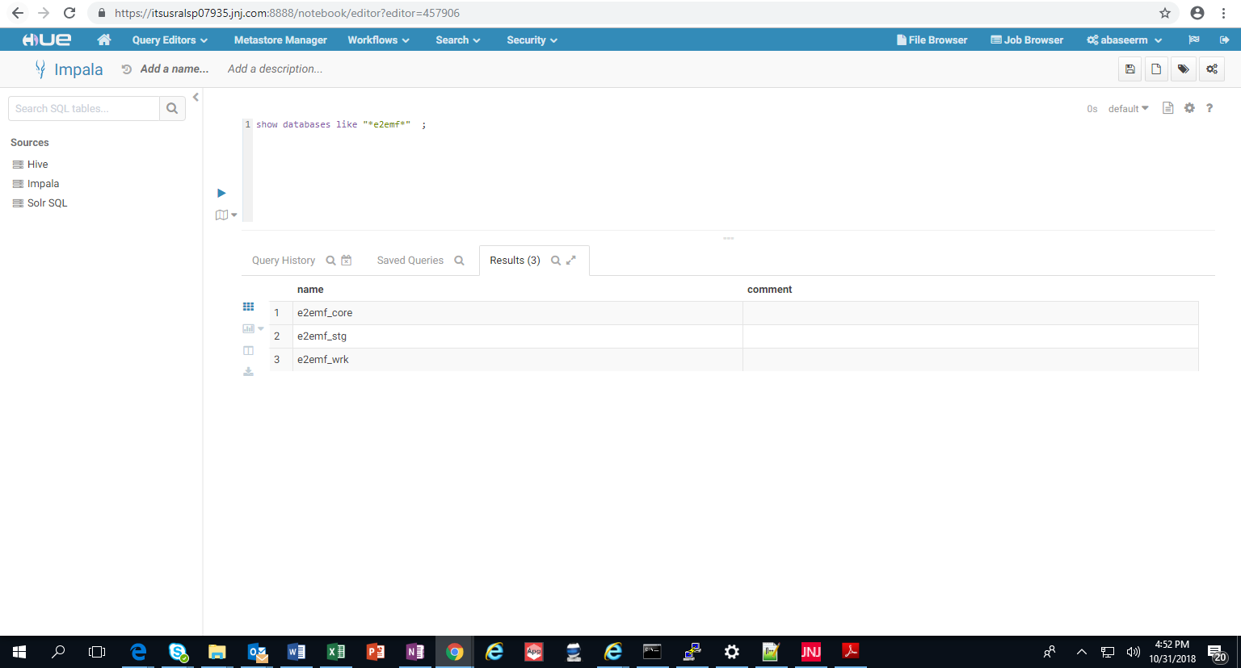
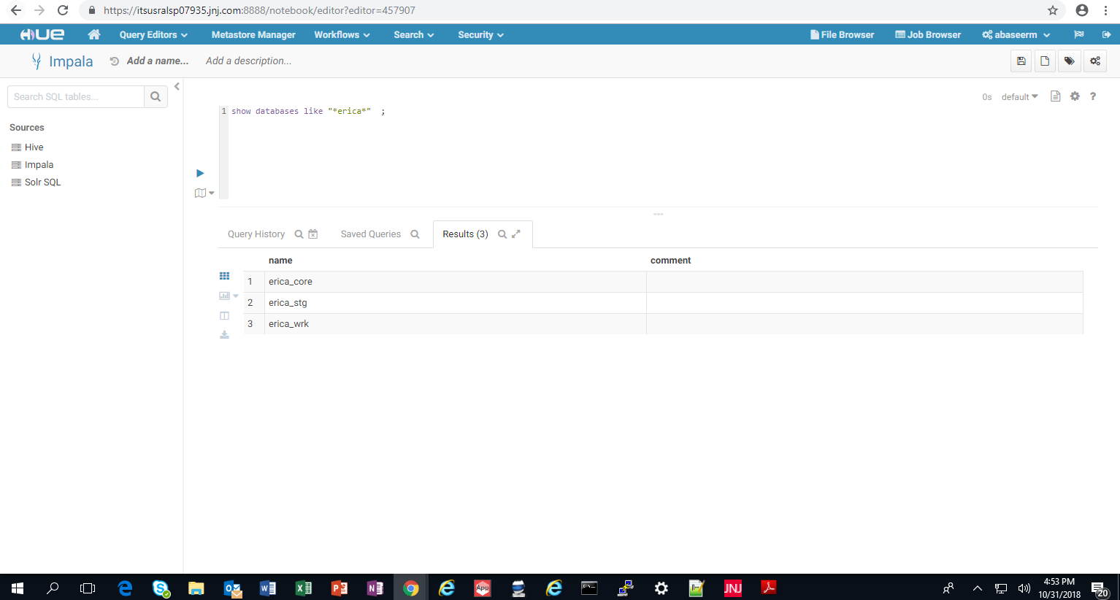

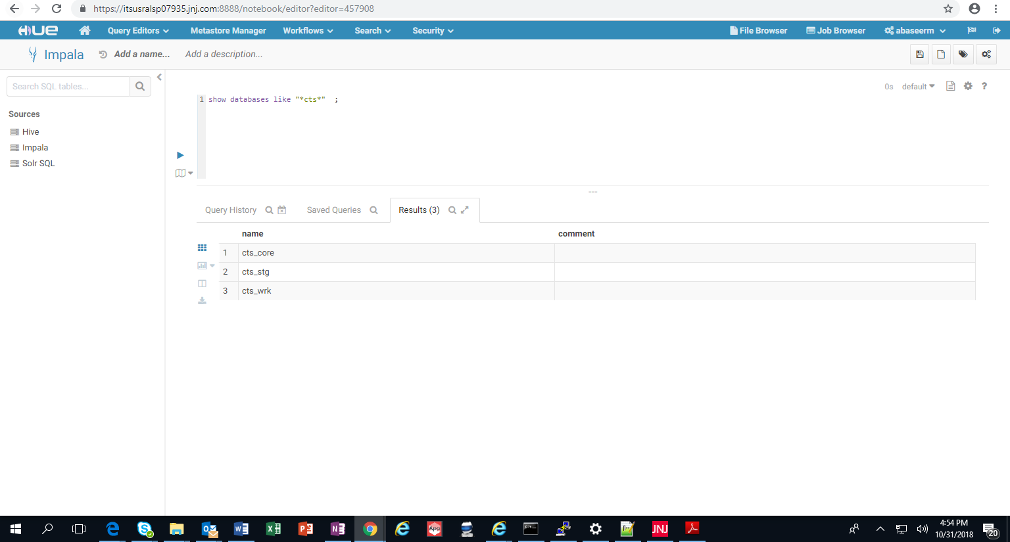

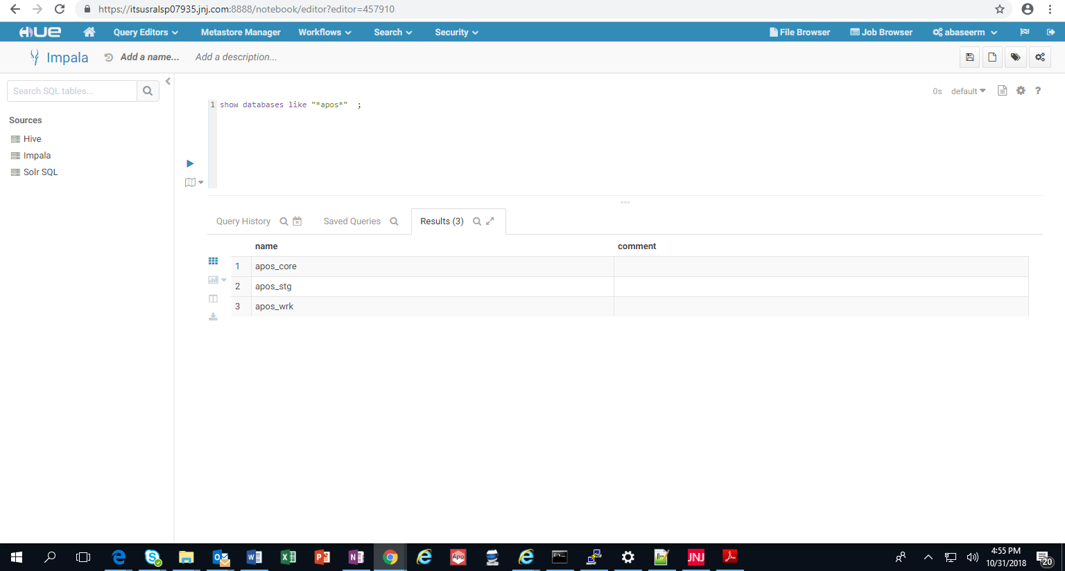

: 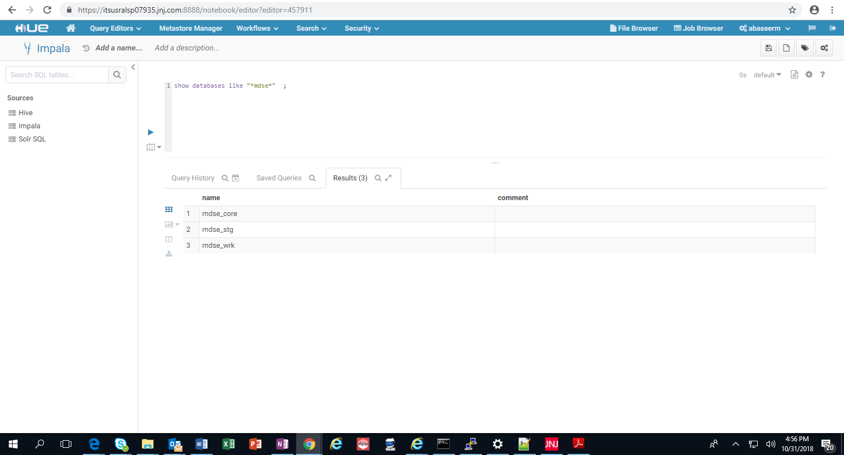

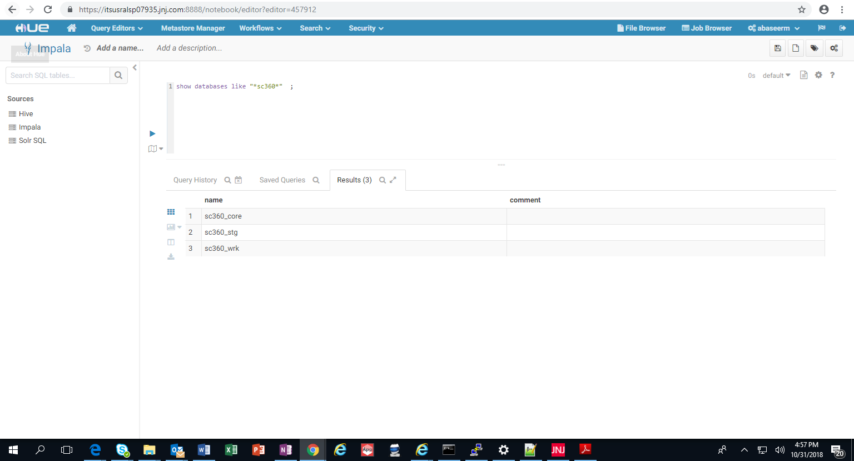

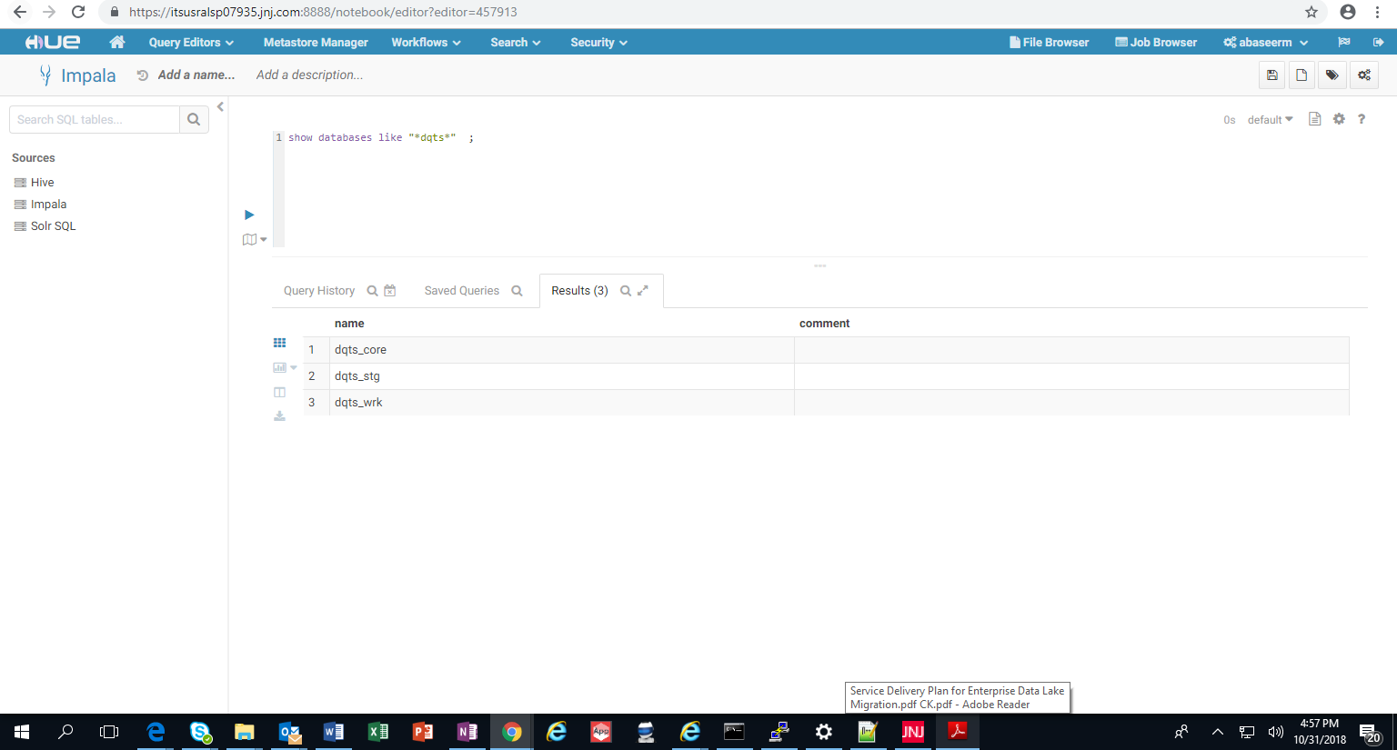

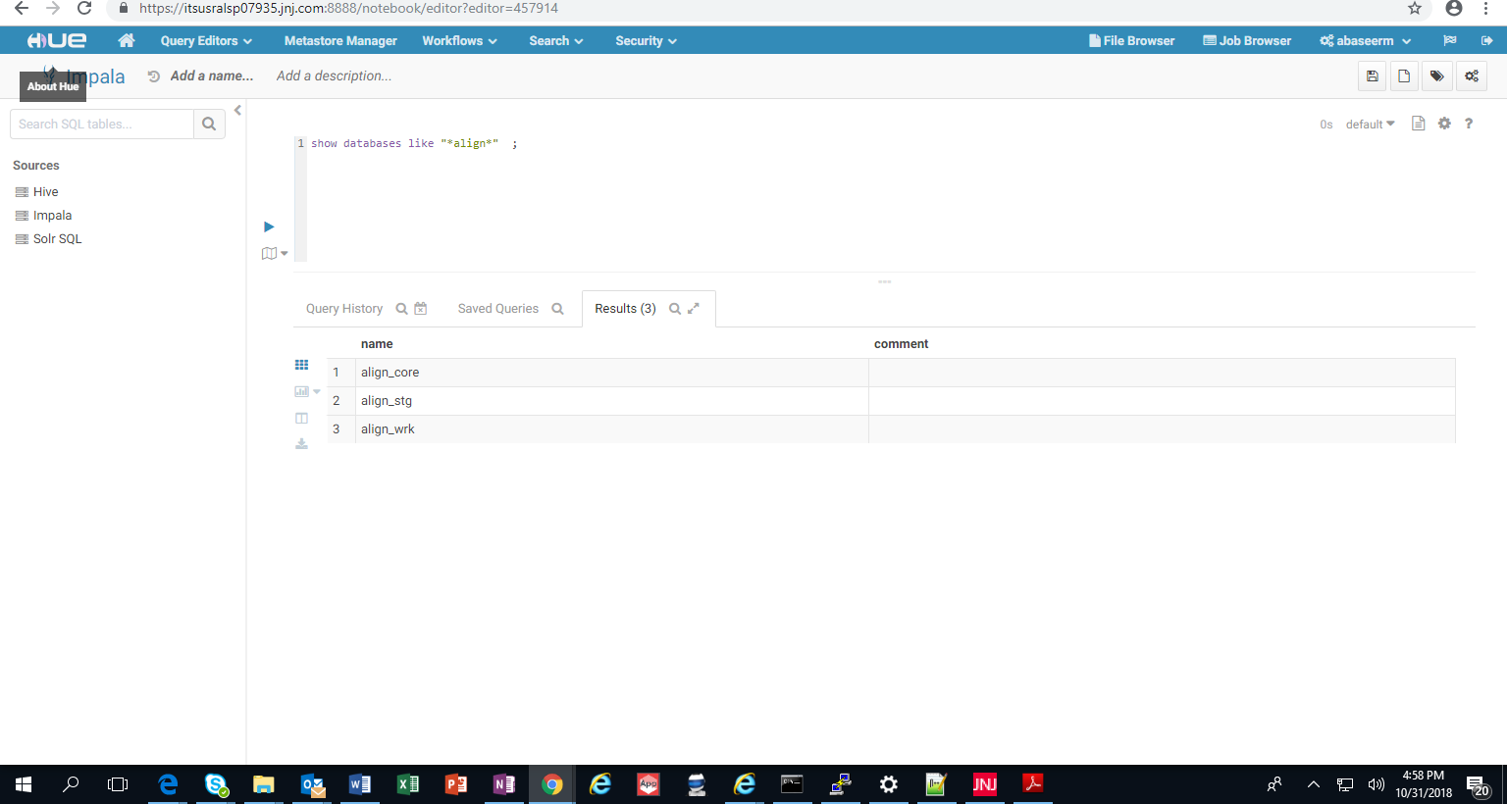



REVISION HISTORY

Version | Date | Author | Change Descriptions
1.0 | 24-Oct 2018 | Sharmila Biswas | Initial version

